**Task Management System**

| **Operation** | **Time Complexity** | **Explanation** |
| --- | --- | --- |
| Add | O(n) | Must traverse to the end to insert |
| Search | O(n) | Linear traversal |
| Display | O(n) | Traverse all elements |
| Delete | O(n) | Must find and unlink the node |

**CODE:**

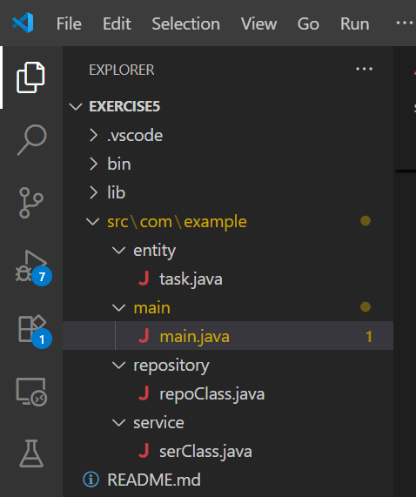

Task.java

package com.example.entity;

public class task {

private int id;

private String taskName;

private boolean status;

public task(int id, String taskName, boolean status) {

this.id = id;

this.taskName = taskName;

this.status = status;

}

public int getId() {

return id;

}

public void setId(int id) {

this.id = id;

}

public String getTaskName() {

return taskName;

}

public void setTaskName(String taskName) {

this.taskName = taskName;

}

public boolean isStatus() {

return status;

}

public void setStatus(boolean status) {

this.status = status;

}

}

Main.java

package com.example.main;

import java.util.Scanner;

import com.example.service.serClass;

public class main {

private static Scanner sc = new Scanner(System.in);

private static main main = new main();

private static serClass ser = new serClass();

public static void main(String args[]) {

boolean flag = true;

while (flag) {

System.out.println();

System.out.println("Task Management System : ");

System.out.println();

System.out.println("1. Add Task");

System.out.println("2. Search a Task");

System.out.println("3. Display all Task");

System.out.println("4. Delete a Task");

System.out.println("5. Exit");

System.out.println();

System.out.print("Enter a option/choice = ");

int n = sc.nextInt();

sc.nextLine();

System.out.println();

switch (n) {

case 1:

main.addTask();

break;

case 2:

main.searchTask();

break;

case 3:

main.display();

break;

case 4:

main.delete();

break;

case 5:

System.out.println("Logged out...");

flag = false;

break;

default:

System.out.println("Invalid option.");

break;

}

System.out.println();

}

}

private void addTask() {

System.out.print("Enter the task id = ");

int n = sc.nextInt();

sc.nextLine();

System.out.print("Enter the task name = ");

String task = sc.nextLine();

ser.addTask(n, task);

}

private void searchTask() {

System.out.print("Enter the task id = ");

int id = sc.nextInt();

sc.nextLine();

ser.searchTask(id);

}

private void display()

{

ser.display();

}

private void delete()

{

System.out.print("Enter the task id = ");

int n = sc.nextInt();

sc.nextLine();

ser.delete(n);

}

}

repoClass.java

package com.example.repository;

import com.example.entity.task;

public class repoClass {

private class Node {

task data;

Node next;

Node(task data) {

this.data = data;

this.next = null;

}

}

private Node head;

public void addTask(int id, String task) {

if (isduplicate(id)) {

System.out.println();

System.out.println("Task already exists....");

return;

}

boolean status = false;

task newtask = new task(id, task, status);

Node newNode = new Node(newtask);

if (head == null) {

head = newNode;

} else {

Node temp = head;

while (temp.next != null) {

temp = temp.next;

}

temp.next = newNode;

}

System.out.println();

System.out.println("Task added Successfully...");

}

private boolean isduplicate(int id) {

Node temp = head;

while (temp != null) {

if (temp.data.getId() == id) {

return true;

}

temp = temp.next;

}

return false;

}

public void searchTask(int id) {

System.out.println();

Node temp = head;

while (temp != null) {

if (temp.data.getId() == id) {

System.out.println("Task found.");

System.out.println("Id = " + temp.data.getId() + "\t TaskName = " + temp.data.getTaskName()

+ "\t Status = " + temp.data.isStatus());

return;

}

}

System.out.println("Task not found.");

}

public void display() {

System.out.println();

if (head == null) {

System.out.println("No Task Available...");

} else {

Node temp = head;

System.out.println("Id \t TaskName \t Status");

System.out.println("----------------------------------------------");

while (temp != null) {

System.out.println(temp.data.getId() + "\t" + temp.data.getTaskName() + "\t\t" + temp.data.isStatus());

temp = temp.next;

}

}

}

public void delete(int id) {

System.out.println();

if (head == null) {

System.out.println("No task Available.");

return;

}

if (!isduplicate(id)) {

System.out.println("Task id not Available...");

return;

}

if (head.data.getId() == id) {

head = head.next;

} else {

Node prev = head;

Node curr = head.next;

while (curr != null) {

if (curr.data.getId() == id) {

prev.next = curr.next;

break;

}

prev = prev.next;

curr = curr.next;

}

}

System.out.println("Task deleted Successfully..");

}

}

serClass.java

package com.example.service;

import com.example.repository.repoClass;

public class serClass {

private static repoClass repo = new repoClass();

public void addTask(int id, String task) {

repo.addTask(id, task);

}

public void searchTask(int id) {

repo.searchTask(id);

}

public void display() {

repo.display();

}

public void delete(int id) {

repo.delete(id);

}

}

## **Output :**

|  |  |
| --- | --- |
|  |  |